

REPUBLIQUE DU CAMEROUN

Paix-Travail-Patrie

MINISRE DE L’ENSEIGNEMENT SUPERIEURE

FACULTE D’ENGENIERE ET DE TECHNOLOGIE

REPUBLIC OF CAMEROON

Peace-Work-Fatherland

MINISTER OF HIGHER EDUCATION

FACULTY OF ENGINEERING AND TECHNOLOGY

**DEPARMENT OF COMPUTER ENGINEERING**

**Instructor: DR NKEMENI VALERY**

**COURSE** **TITLE**: Internet and Mobile Programming

PROGRAMMING

**GROUP MEMBERS**

|  |  |
| --- | --- |
| **Names Matricule** | |
| ETOH KIERA EKUTY | FE20A035 |
| GWANA JUSLINE AKAH | FE20A047 |
| LASSI FOKOU BERICE JILDO | FE20A054 |
| YUVEN BRIAN | FE20A125 |
| AJONG NTI MAGCELOUS | FE20A006 |
|  |  |

**UI DESIGN AND IMPLEMENTATION OF MARKET MANAGEMENT SYSTEM**

**Introduction**

The purpose of this report is to present the UI design and implementation for a market management system. The system is designed to provide buyers and sellers a convenient way to buy and sell products in the market by giving the sellers a broader audience for their products and providing the buyers with the location and price of a particular product before they go to the market, thereby saving them the stress and energy they would waste roaming around the market in search of a particular product. The report will cover the design process, the tools used, and the final implementation of the UI.

**Design Process**

The design process began with a thorough analysis of the requirements of the market management system. This involved identifying the key features that the system needed to have, such as product listing, product search, location and price ranges. Once these features were identified, the design team began working on creating the UI Design of the system.

The UI was created using Figma. This tool allowed the team to quickly iterate on different design ideas. The team also conducted user testing to ensure that the UI was easy to use and intuitive. Once the UI Design was finalized, the team began working on creating a visual design for the UI. The design was based on a modern and clean aesthetic, with a focus on usability and functionality.

**Designs from Figma:**

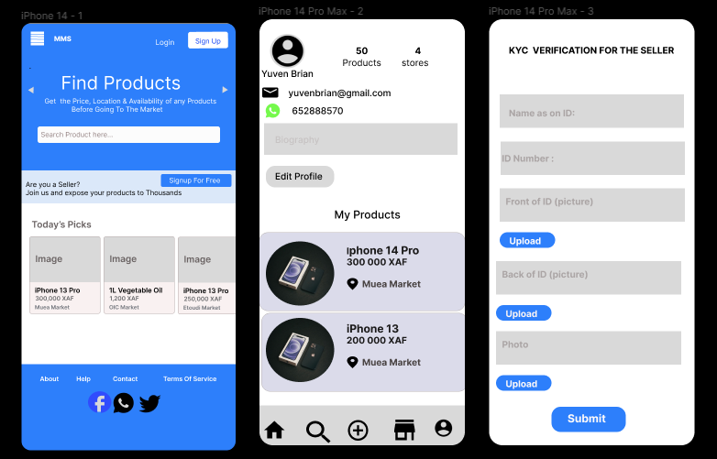

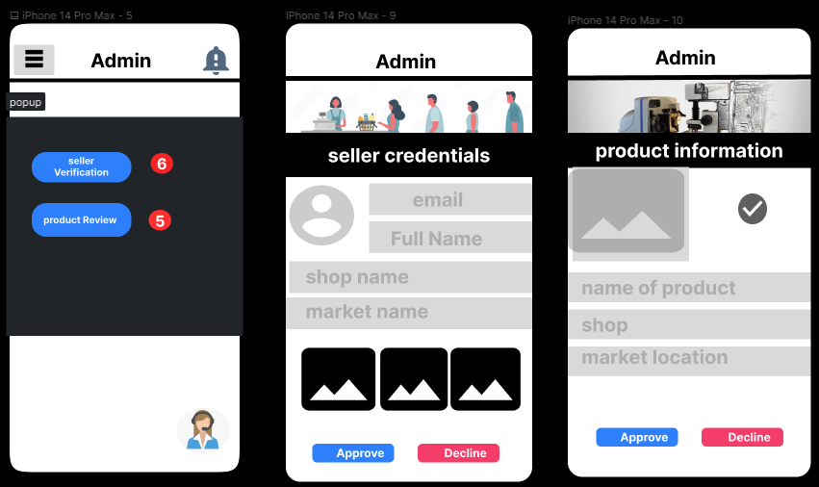

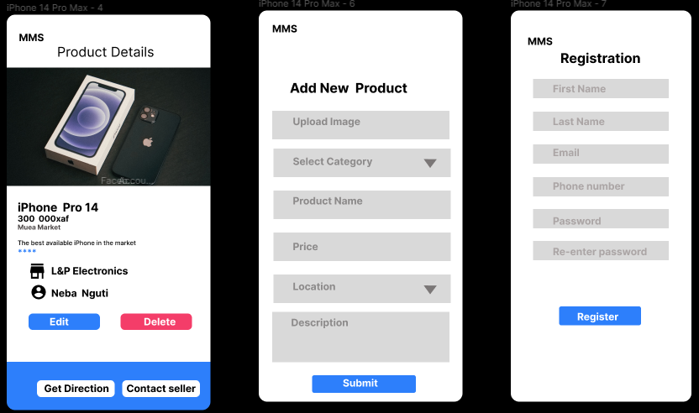

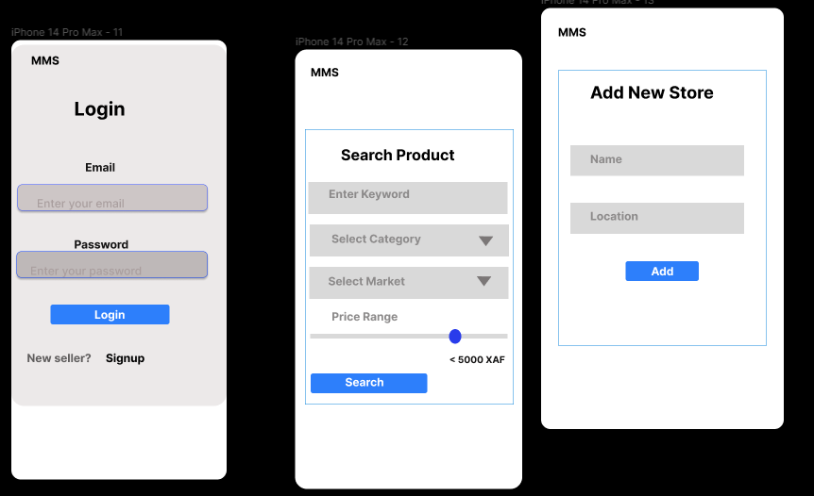

**Tools Used**

The UI was designed using Figma. This tool allowed the team to quickly iterate on designs.

The final implementation of the UI was done using HTML, CSS, and JavaScript. The team used the Bootstrap framework to create a responsive and dynamic UI.

**Implementation of UI Designs for a Market Management System**

The final implementation of the UI was based on the designs created during the design process. The UI was designed to be intuitive and easy to use, with a focus on functionality and usability.

The following are the pages that were designed from Figma, and will be explained in detail below:

1. **Landing Page**: The Landing page is the first page that users see when they open the Market Management system application. It displays an aesthetically pleasing and welcoming feeling to the user. It contains introductory information about the system that includes its benefits.

2. **User Profile Page:** The User profile page allows users to view their personal details like their name, picture, email address, phone number, products they have available for sale. This is where users can personalize their settings according to their preference, and can manage their profile.

3. **KYC Verification for Sellers Page**: This page is essential for sellers who want to make their products available on the Market Management system. They have to upload valid identification documents like valid Driver’s License, International passport, or National ID Card and a picture of them holding any of the documents. Once completed, the Market Management team verifies the documents uploaded by the seller to ensure that they are valid.

4**. Admin Page**: The admin page is where the administrator manages the system. The administrator has access to every feature of the system. They can modify, update, and delete sellers and products.

**5. Product Details Page:** This page contains specific details about the product being sold. Such details include product name, image(s), price, product description, availability, location, product category, and reviews. Users can make inquiries about products by sending messages directly to the seller from this page.

**6. Add a New Product Page**: This page allows registered sellers to add new products to the Market Management system. They input the product's information like product name, image(s), price, product description, availability, location, and product category.

**7. Registration Page:** The registration page gives access to sellers, and administrators to register on the system. They provide their personal information like name, email address, password, and confirm the password.

**8. Login Page**: This page gives registered sellers and administrator's access to the Market Management system by inputting their login credentials like email address and password.

9. **Search Product Page:** Users can search for specific products they wish to buy from the Market Management system on this page.

**10. Add New Store Page:** This page allows approved sellers to add new stores to the system. They would have to upload the store name, description and location details along with pictures. Once uploaded, the Market Manager team verifies the details before the store can be seen on the platform.

**Conclusion**

Overall, the design and implementation of UI for a market management system has been a success. The pages created using Figma have been carefully crafted to meet the needs of both buyers and sellers. From the landing page to the search product page, each page has been designed with the user in mind, providing a seamless and intuitive experience. The system's administrators have also been given the tools they need to manage the platform effectively. With this UI design, the market management system is well-positioned to serve its users and achieve its goals.